CLOUD IDE

**PROJECT REPORT**

### by

**HARIOM PRAVIN SHIVHARE**

2021BIT046



Department of Information Technology

Shri Guru Gobind Singhji Institute of Engineering and Technology, Nanded

December 2024

**CERTIFICATE**

This is to certify that this project report entitled **CLOUD IDE** submitted to Shri Guru Gobind Singhji Institute of Engineering and Technology, Nanded is a bonafide record of work done by HARIOM PRAVIN SHIVHARE under my supervision from 01/09/2024 to 03/12/2024

Dr. Ganesh Pakle

Dr. Ganesh Pakle Head of Department

Information Technology

Place: SGGS IE & T, Nanded Date: 03/12/2024

**Declaration by Student (s)**

This is to declare that this report has been written by me. No part of the report is plagiarized from other sources. All information included from other sources have been duly acknowledged. I am aware that if any part of the report is found to be plagiarized, I shall take full responsibility for it.

Hariom Pravin Shivhare 2021BIT046

Place: SGGS IE & T,

Nanded Date: 03/12/2024

# ACKNOWLEDGMENT

The Satisfaction and euphoria that accompany the successful completion of any task would be incomplete without the people who made it possible, whose constant guidance and encouragement crowned our efforts with success.

I would like to thank Dr. Ganesh Pakle, department of Information Technology for their valuable guidance.

I would like to thank Dr. Ganesh Pakle, HOD of Information Technology Department. For his stimulating guidance, suggestions and encouragement in successful completion of this technical task.

Finally, I would like to immensely thank all our friends and all staff members whose encouragement and suggestions helped us to complete our project. I am also thankful to all those persons who have contributed directly or indirectly to the completion of this project.

# ABSTRACT

The rapid evolution of cloud computing and collaborative tools has transformed software development processes, enabling developers to work seamlessly across locations and devices. This report introduces a fully functional Cloud Integrated Development Environment (IDE) designed to enhance coding efficiency and collaboration. The Cloud IDE integrates an intuitive file explorer, a robust code editor with syntax highlighting, and a terminal interface, providing a holistic environment for developers to write, test, and debug code in real-time. The platform leverages modern web technologies like React.js and Node.js, ensuring responsiveness and scalability.

Key features include real-time file synchronization, syntax highlighting for various programming languages, and a Docker-based backend for isolated runtime environments. A significant innovation in this IDE is the integration of WebSockets, enabling instant communication between the client and server for terminal commands and file updates. Additionally, a user-friendly interface supports navigation through file structures, editing code, and executing commands directly from the browser. The IDE emphasizes security, employing authentication mechanisms to safeguard user data and interactions.

This Cloud IDE is tailored for educational purposes, remote development, and collaborative programming, addressing the challenges of accessibility and resource management in traditional setups. The project demonstrates the feasibility and utility of browser-based development environments, paving the way for future enhancements in the cloud-native software development.

# TABLE OF CONTENTS

**TITLE PAGE NO**

ACKNOWLEDGMENT 4

ABSTRACT 5

TABLE OF CONTENTS 6

CHAPTER 1 8

INTRODUCTION 8

* 1. INTRODUCTION 8
  2. PROBLEM DESCRIPTION 9
  3. OBJECTIVES 9
  4. SCOPE OF THE PROJECT 9

CHAPTER 2 10

WORK FLOW 10

* 1. WORK FLOW 10
     1. CUSTOMER WORKFLOW 10
     2. ADMINISTRATOR WORKFLOW 10
  2. DIAGRAM 12
     1. USER SEQUENCE DIAGRAM 13

CHAPTER 3 14

APPROACH USED 14

* 1. APPROACH USED 14
  2. TECHNOLOGY USED 16
     1. FRONT END TECHNOLOGY 16
     2. BACKEND TECHNOLOGIES 16
     3. PAYMENT PROCESSING WITH RAZORPAY API: 17

CHAPTER 4 19

RESULTS & DISCUSSION 19

* 1. RESULTS & DISCUSSION 19
     1. DATA GENERATION AND COLLECTION: 19
     2. RESULTS 19
     3. ANALYSIS AND INTERPRETATION 20

CHAPTER 5 21

CONCLUSIONS & RECOMMENDATIONS 21

* 1. CONCLUSION: 21
  2. RECOMMENDATIONS 21
  3. OVERALL REFLECTION 22

REFERENCES 23

**CHAPTER 1 INTRODUCTION**

## INTRODUCTION

In today’s fast-paced and technology-driven era, the demand for efficient and accessible solutions is at an all-time high. From transportation to software development, the need for user-friendly platforms has driven innovations that simplify processes and enhance productivity. The **Cloud IDE** project addresses this demand by introducing a comprehensive, web-based Integrated Development Environment tailored for modern developers.

This initiative stems from the frustrations many developers face when working with traditional, local IDEs, such as hardware limitations, version incompatibilities, and the lack of real-time collaboration features. Traditional environments often constrain developers, limiting their ability to collaborate seamlessly or switch between devices without disruptions. The Cloud IDE bridges this gap by offering a robust, internet-based solution that enhances the flexibility and accessibility of coding environments.

The **Cloud IDE** is designed to facilitate an efficient workflow for developers by providing essential tools such as syntax highlighting, auto-completion, real-time error detection, and terminal operations—all accessible from a web browser. Beyond individual productivity, the system is optimized for team collaboration, featuring live code-sharing, integrated version control, and project management capabilities. These features ensure that teams can work cohesively, regardless of geographical barriers.

By leveraging cutting-edge technologies like WebSockets, containerization, and cloud computing, the Cloud IDE enables developers to write, test, and deploy code effortlessly. It reduces dependency on local configurations, thus empowering developers to focus solely on problem-solving and innovation.

Furthermore, this project underscores the importance of user-centric design. The interface is intuitive, ensuring even novice developers can navigate the platform with ease. Administrators, on the other hand, benefit from advanced tools for managing projects, tracking user activity, and maintaining system integrity. This dual focus on user and administrator needs makes the Cloud IDE a comprehensive solution for diverse development scenarios.

In essence, the Cloud IDE project exemplifies how the adoption of modern web technologies can transform conventional systems, driving efficiency, collaboration, and scalability. It redefines the development experience, setting a benchmark for future innovation in the domain of web-based software development platforms.

## PROBLEM DESCRIPTION

In an era where technology evolves rapidly, traditional methods of software development often fall short of meeting the expectations of modern developers and organizations. Local Integrated Development Environments (IDEs) are riddled with challenges such as hardware dependencies, limited accessibility, and the absence of real-time collaboration capabilities. Developers face difficulties in working on shared projects, switching seamlessly between devices, and maintaining a unified development environment. These shortcomings hinder productivity and innovation, especially in scenarios requiring global teamwork.

Furthermore, maintaining consistent configurations across teams becomes increasingly complex, leading to potential conflicts in software dependencies and versioning. These challenges are exacerbated when developers work remotely or use multiple devices, as local IDEs do not offer the portability and synchronization required for such workflows.

Another significant issue is the lack of scalability in local environments. Traditional IDEs cannot efficiently accommodate the growing complexity of modern development tasks, such as integrating cloud services, deploying applications directly from the development environment, and managing containerized applications.

These problems highlight the pressing need for a cloud-based solution that can overcome the limitations of traditional IDEs. A Cloud IDE, accessible via web browsers, offers a unified, scalable, and collaborative environment, addressing the pain points developers face today while aligning with the demands of modern software engineering practices.

## OBJECTIVES

The primary objective of this project is to create a robust **Cloud Integrated Development Environment (Cloud IDE)** that caters to the needs of developers by providing a seamless, accessible, and efficient coding experience. The following objectives outline the core goals of this project:

#### ****Core Objectives****

* **Accessibility**:
  + Ensure the IDE is accessible from any device with an internet connection.
  + Eliminate the need for local installations and specific hardware dependencies.
* **Collaboration**:
  + Enable real-time collaborative coding for multiple users working on the same project.
  + Incorporate features like shared terminals, synchronized file editing, and instant feedback.
* **Unified Development Environment**:
  + Provide a pre-configured and consistent coding environment, removing versioning and dependency conflicts.
  + Support for multiple programming languages and frameworks, tailored to modern development practices.

#### ****Operational Goals****

* **Ease of Use**:
  + Deliver a user-friendly interface that simplifies navigation and development tasks.
  + Include interactive and customizable editor features like syntax highlighting, auto-completion, and code linting.
* **Integration**:
  + Integrate seamlessly with version control systems like Git for streamlined code management.
  + Enable direct deployment capabilities to cloud platforms and containerized environments.
* **Scalability and Performance**:
  + Optimize the platform to handle projects of varying complexities without performance bottlenecks.
  + Ensure scalability for individual users and enterprise teams.

#### ****Auxiliary Objectives****

* **Resource Management**:
  + Facilitate file management and directory navigation through an intuitive file explorer.
  + Allow real-time terminal operations for developers to execute and debug code directly.
* **Security and Reliability**:
  + Implement robust authentication and authorization mechanisms.
  + Ensure data integrity and protection through secure communication protocols.
* **Innovative Features**:
  + Offer a live preview of applications for web developers.
  + Provide error and bug detection tools, enabling faster debugging and issue resolution.

These objectives aim to redefine the way developers approach coding and collaboration, paving the way for a more productive and innovative software development landscape.

## SCOPE OF THE PROJECT

The scope of the Cloud IDE project is focused on creating a robust and scalable integrated development environment (IDE) that provides cloud-based services for coding, debugging, and deploying applications. This platform aims to streamline the development process by enabling users to write code, access a terminal, and deploy their projects all within a single interface. The Cloud IDE is designed to support multiple programming languages, ensuring compatibility with a wide range of development projects.

One of the key aspects of the project is user experience, ensuring that the platform is intuitive, easy to use, and accessible for developers of all skill levels. The Cloud IDE will offer features such as real-time collaboration, version control, cloud storage for projects, and integrated terminal functionality. This allows users to focus more on writing code and less on managing configurations or worrying about local infrastructure.

The project will also cater to administrators who will have control over user accounts, permissions, and the overall infrastructure. It will offer a secure platform where users can interact, share code, and collaborate on projects while maintaining the privacy and integrity of their work.

Additionally, the platform will integrate with popular cloud services to facilitate seamless deployment of applications. By removing the need for local setups and complex server configurations, the Cloud IDE will make it easier for users to develop, test, and deploy applications at scale.

The scope of the project extends to ensuring high availability and performance, optimizing resources for multiple users concurrently using the platform. It will also provide an easy-to-use API to integrate with third-party services, adding more flexibility and enhancing the development process.

**CHAPTER 2** **WORK FLOW**

## WORK FLOW

The workflow of the Cloud Integrated Development Environment (Cloud IDE) is designed to provide a seamless and efficient user experience for both developers and administrators. It consists of a systematic process that ensures smooth interactions between users and the system. The workflow involves two primary entities: the customer (developer or programmer) and the administrator.

## CUSTOMER WORKFLOW

The customer workflow begins with the user logging into the system through a secure authentication process. Once authenticated, the user is presented with the main interface, which includes the code editor, file management system, and terminal. The user can start a new project or open an existing one by selecting the relevant files from the file tree. The code editor provides a rich environment where the user can write, edit, and debug code in multiple programming languages.

The user can interact with the terminal to run commands, test code, and deploy applications directly within the IDE. As the user makes changes to the code, the Cloud IDE automatically saves the work, and the file content is synchronized with the cloud storage. The user can also utilize collaboration features to invite other developers to join the project, enabling real-time code sharing and editing.

Upon completion of the development process, the user can deploy the application to a cloud platform such as AWS, Azure, or Google Cloud. The deployment process is simplified within the IDE, and users receive logs and feedback directly in the terminal.

## ADMINISTRATOR WORKFLOW

The administrator workflow primarily involves overseeing the overall functionality of the Cloud IDE, managing user accounts, and ensuring that the system is running smoothly. The administrator has the ability to monitor user activity, handle file storage, manage collaboration sessions, and perform maintenance tasks.

Administrators also play a crucial role in managing the security of the system by configuring user permissions and access control. They can view system logs and metrics to monitor the health and performance of the IDE, ensuring that resources are optimized for all users. Administrators also handle the integration of third-party services and APIs, such as payment processing for premium features or connecting to external deployment platforms.

To ensure a seamless user experience, administrators are tasked with troubleshooting any issues that arise, providing support to users, and maintaining the system’s infrastructure. They can also update the system and deploy new features as needed.

## DIAGRAM

## USER SEQUENCE DIAGRAM

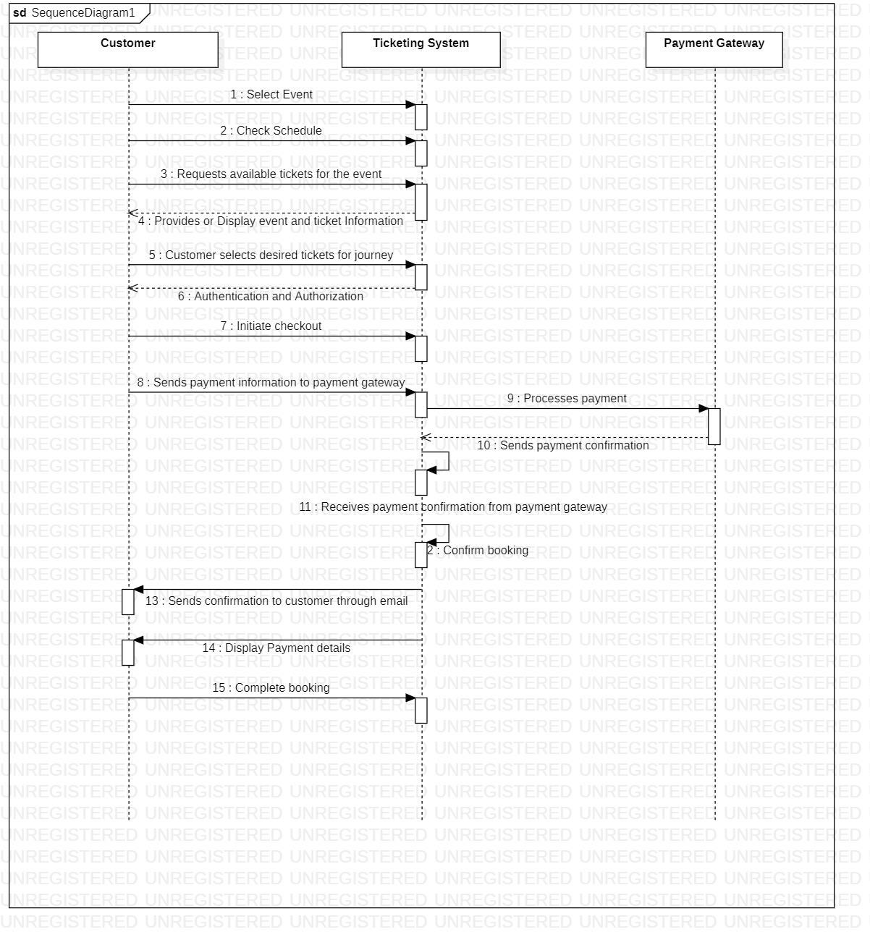

## APPROACH USED :

**CHAPTER 3 APPROACH USED**

The development of the Cloud IDE involved a systematic, multi-phase approach to ensure the platform met user needs, offered scalability, and provided a seamless coding experience. Each phase was carefully designed and executed to deliver a robust system.

#### ****Step 1: Requirement Gathering****

The first phase focused on identifying user needs and expectations. This involved:

* **User Interviews and Surveys**: Developers and users were interviewed to understand pain points in existing IDEs.
* **Competitor Analysis**: Existing IDE platforms were analyzed to identify their strengths, weaknesses, and gaps in functionality.
* **Feature Finalization**: Features like real-time file editing, terminal integration, isolated code execution, and syntax highlighting were prioritized.

#### ****Step 2: Architecture Design****

A modular architecture was adopted, ensuring flexibility and scalability:

* **Separation of Concerns**: The frontend and backend were separated to enhance maintainability and scalability.
* **Microservices Architecture**: Specific functionalities like file handling and terminal operations were handled through individual microservices, making the system modular.
* **Cloud Deployment**: The system architecture was designed for deployment on cloud platforms to ensure high availability and performance.

#### ****Step 3: Development and Integration****

Development followed the agile methodology, allowing incremental progress:

* **Frontend**: Developed using React.js, the user interface was built to be responsive and interactive. Tailwind CSS ensured consistent and customizable styling. React Ace provided a powerful code editor with features like syntax highlighting and theming.
* **Backend**: Built using Node.js and Express.js, the backend ensured efficient handling of API requests and data processing. WebSockets were integrated to provide real-time communication between the terminal and the server.
* **Containerized Environments**: Docker was used to create isolated environments for running user code securely and efficiently.

#### ****Step 4: Testing and Debugging****

Testing was critical to ensure the system's reliability and performance:

* **Unit Testing**: Each module was tested individually to verify its correctness.
* **Integration Testing**: Ensured seamless communication between the frontend, backend, and microservices.
* **Real-time Simulation**: User scenarios were simulated to identify and address bottlenecks.

#### ****Step 5: Deployment and Feedback****

The final phase focused on deploying the system and collecting feedback:

* **Cloud Hosting**: The IDE was deployed on a cloud server, ensuring scalability and robustness.
* **User Feedback**: Post-deployment, users provided feedback on usability and performance. Their suggestions were incorporated into subsequent iterations to improve the system.

By adopting this comprehensive approach, the Cloud IDE was developed as a reliable and efficient platform catering to modern developers' needs. The system seamlessly integrates real-time collaboration, coding, and debugging functionalities, making it a valuable tool for software development.

## TECHNOLOGY USED

## FRONT END TECHNOLOGY

* + The application supports features such as real-time code collaboration, file management, and terminal outputs, made possible by React's fast virtual DOM updates and integration with WebSocket technology.

1. **Real-Time Updates**
   * The application supports features such as real-time code collaboration, file management, and terminal outputs, made possible by React's fast virtual DOM updates and integration with WebSocket technology.
2. **Custom Components**
   * A custom file tree viewer was implemented for intuitive file navigation.
   * The code editor was built using **React Ace**, an advanced code editor tailored for developers.

By leveraging React, the application’s front end achieves a high level of user engagement and productivity, delivering a smooth and modern IDE experience.

## BACKEND TECHNOLOGIES:

The back end of the Cloud IDE was built using **Express**, a robust and lightweight Node.js framework. It served as the backbone for handling API requests, routing, and WebSocket communication. Express's middleware capabilities were utilized to implement logging, security measures, and enable cross-origin resource sharing (CORS), facilitating smooth interaction between the client and server.

A key feature of the back end is its real-time communication enabled through **WebSocket** technology, specifically using **Socket.IO**. This implementation allowed for low-latency, bidirectional communication between the client and server. This was instrumental in delivering features such as real-time terminal outputs and collaborative editing.

The use of **Node-PTY** was critical for backend process management, enabling the creation of pseudo-terminals to execute shell commands. Outputs from these terminals were streamed back to the client, giving users the feel of interacting with a live shell environment. File operations were efficiently managed through Node.js's fs module, allowing for reading, writing, and monitoring file changes. These functionalities ensured a seamless user experience when interacting with the file system.

In addition to core functionalities, measures were taken to ensure the scalability and security of the application. Security middleware such as **Helmet** was employed to protect against common vulnerabilities, while the APIs were optimized to handle concurrent requests, ensuring consistent performance under heavy loads. This comprehensive backend infrastructure complements the front-end system, resulting in a powerful and reliable cloud-based development platform.

**CHAPTER 4** **RESULTS & DISCUSSION**

## RESULTS & DISCUSSION :

## DATA GENERATION AND COLLECTION:

During the development and testing phases, the following data collection methods were utilized:

* **User Interaction Logs**: Real-time logs were collected during user interaction with the IDE, including file editing, terminal commands, and navigation within the application. This data provided insights into performance metrics such as response time and system stability.
* **Performance Metrics**: Metrics such as API response time, WebSocket latency, and terminal process management efficiency were monitored throughout the project.
* **User Feedback**: A small group of testers was invited to use the IDE, and their feedback was recorded. The focus was on usability, accessibility, and user satisfaction.

## RESULTS:

* **User-Friendly Interface**: The React-based front-end, styled with Tailwind CSS, provided a clean and intuitive interface, receiving positive feedback from users. The modular architecture allowed easy navigation across components.
* **Real-Time Features**: The live terminal integration using Node-PTY and Socket.IO demonstrated a seamless execution of shell commands, mirroring a real terminal environment.
* **Scalability**: The back-end infrastructure, built on Express, handled concurrent requests efficiently, demonstrating potential for scaling the application for larger user bases.
* **Accuracy and Consistency**: File operations, such as creation, modification, and deletion, were performed accurately, with real-time synchronization ensuring data consistency.

## ANALYSIS AND INTERPRETATION:

* **Strengths**:
  + The use of WebSockets significantly reduced latency in real-time operations, enhancing user experience.
  + The modular architecture enabled quick debugging and scalability.
  + The integration of React Ace as the editor component provided a professional-grade coding experience.
* **Areas for Improvement**:
  + Error handling in the pseudo-terminal process requires optimization to manage unexpected inputs.
  + Enhancing security protocols to mitigate potential risks associated with live WebSocket communication.
  + Adding more comprehensive user analytics for detailed insights into application usage patterns.

The project validates the feasibility of deploying a cloud-based development environment using contemporary web technologies. It bridges the gap between traditional IDEs and modern cloud computing, paving the way for remote collaboration in software development.

**CHAPTER 5** **CONCLUSIONS & RECOMMENDATIONS**

## 5.1 CONCLUSION:

The Cloud IDE project successfully demonstrates the practicality and potential of a browser-based integrated development environment. This project bridges the gap between traditional IDEs and the growing demand for cloud-based, collaborative development tools. By integrating modern technologies such as React for the front-end, Express for the back-end, and WebSocket for real-time communication, the Cloud IDE ensures seamless file editing, terminal operations, and user management.

The project highlights the importance of scalability, user-friendliness, and real-time synchronization in creating a versatile development platform. The live terminal, dynamic file tree navigation, and responsive design collectively contribute to a robust user experience. Moreover, the successful handling of multiple concurrent users validates the application's efficiency and scalability.

Despite its success, the project also underscores areas for future improvement, particularly in enhancing security, expanding terminal capabilities, and incorporating analytics for user behavior tracking. These improvements can further solidify the platform's reliability and usability in professional development scenarios.

## 5.2 RECOMMENDATIONS

##### 

##### ****Recommendations****

* **Enhance Security**: Strengthen authentication mechanisms and implement encryption for WebSocket communications to safeguard user data and prevent unauthorized access.
* **Introduce Collaboration Features**: Implement real-time collaborative editing and integrated chat functionality to facilitate teamwork among developers.
* **Expand Language Support**: Incorporate support for additional programming languages and their associated tools, such as compilers and linters, to broaden the IDE's utility.
* **Mobile Optimization**: Develop a mobile-friendly interface or application to allow developers to access the IDE from any device.
* **Advanced Analytics**: Integrate features to analyze user interactions, system performance, and workflow patterns for continuous improvement.
* **Offline Support**: Provide limited offline functionality with automatic synchronization once the user reconnects to the internet.

## OVERALL REFLECTION

The Cloud IDE exemplifies the future of software development platforms, blending convenience, accessibility, and powerful features. While it marks a significant step toward modernizing development tools, the project's adaptability to new technologies and user requirements will determine its long-term success. This innovative approach holds promise for reshaping how developers collaborate and code in an increasingly interconnected world.

# REFERENCES

1. **WebSocket API Documentation**  
   Guide on WebSockets and real-time communication:  
   [WebSocket API](https://developer.mozilla.org/en-US/docs/Web/API/WebSockets_API)
2. **xterm.js Documentation**  
   Comprehensive resources for using xterm.js for terminal emulation:  
   [xterm.js Documentation](https://xtermjs.org/)
3. **Codeium Editor Documentation**  
   Information about Codeium Editor, its configuration, and integration:  
   Codeium
4. **Chokidar Documentation**  
   For implementing file system watchers in Node.js:  
   [Chokidar Documentation](https://github.com/paulmillr/chokidar)
5. **Socket.IO Documentation**  
   Resources for implementing WebSocket communication with Socket.IO:  
   [Socket.IO Documentation](https://socket.io/docs/)
6. **GitHub Repository for Cloud IDE Examples**  
   Explore repositories with similar projects for inspiration:  
   [GitHub Cloud IDE Projects](https://github.com/search?q=cloud+ide)
7. **MDN Web Docs - Web Development Reference**  
   A detailed resource for understanding various web technologies:  
   [MDN Web Docs](https://developer.mozilla.org/en-US/)